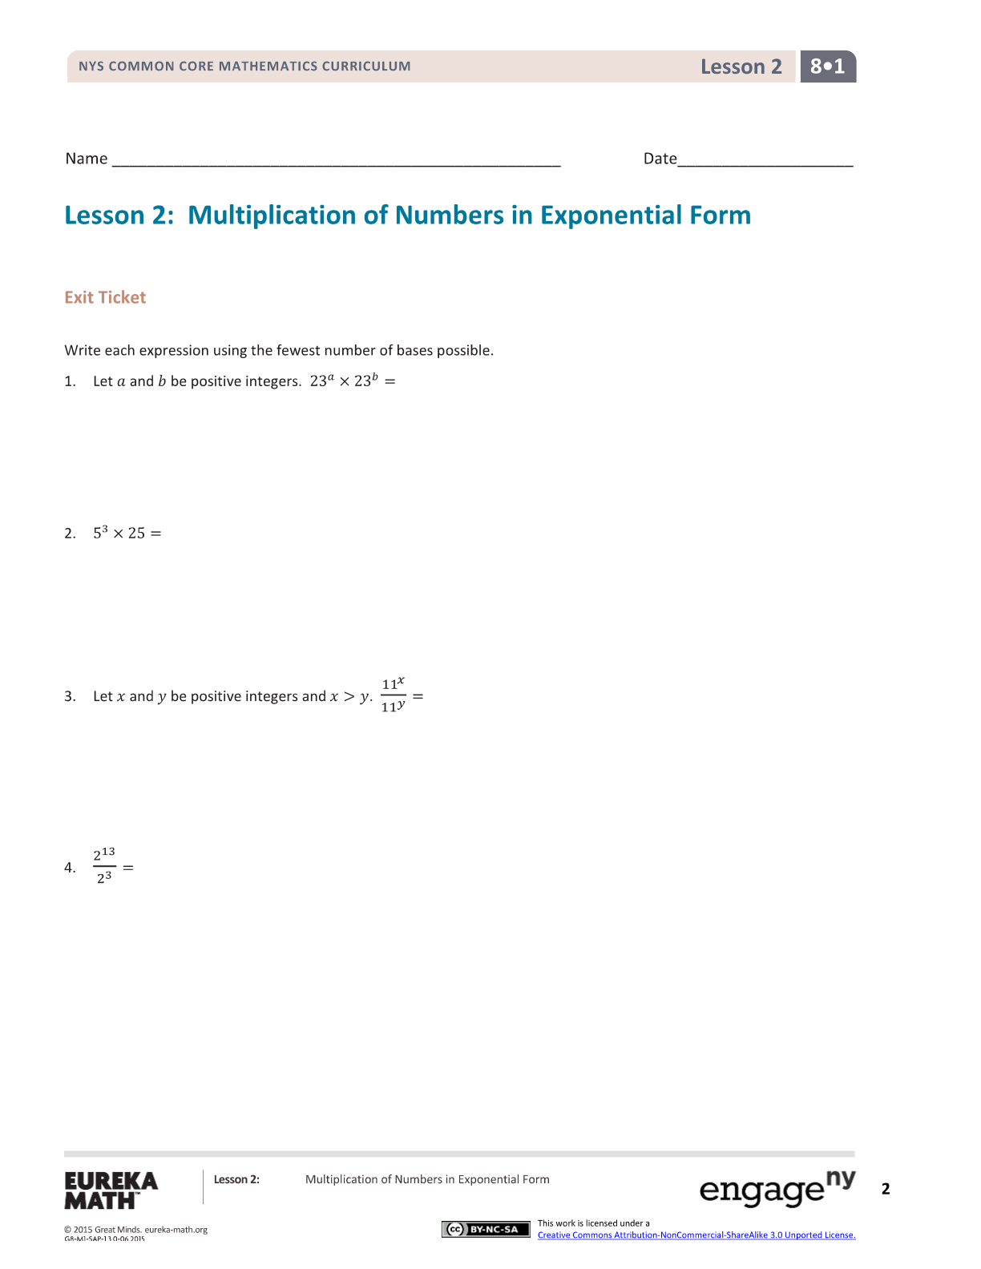
- Let $a$ and$b$ be numbers and $b≠0$, and let $m$and $n$ be positive integers. Write each expression using the fewest number of bases possible:
$${\left(-19\right)}^{5}∙{\left(-19\right)}^{11}=$$ | $${2.7}^{5}×{2.7}^{3}=$$
$$\frac{7^{10}}{7^{3}}=$$ | $${\left(\frac{1}{5}\right)}^{2}∙{\left(\frac{1}{5}\right)}^{15}=$$
$${\left(-\frac{9}{7}\right)}^{m}∙{\left(-\frac{9}{7}\right)}^{n}=$$ | $$\frac{ab^{3}}{b^{2}}=$$

- Let the dimensions of a rectangle be $\left(4×{\left(871209\right)}^{5}+ 3×49762105\right) ft.$ by $\left(7×{\left(871209\right)}^{3}-{\left(49762105\right)}^{4}\right) ft.$ Determine the area of the rectangle. (Hint: You do not need to expand all the powers.)

- A rectangular area of land is being sold off in smaller pieces. The total area of the land is $2^{15}$ square miles. The pieces being sold are $8^{3}$ square miles in size. How many smaller pieces of land can be sold at the stated size? Compute the actual number of pieces. (hint: change the $8^{3}$ to a base with 2 first)

